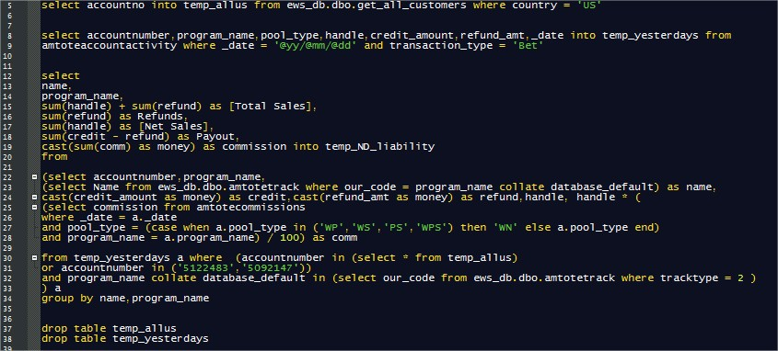

|  |  |
| --- | --- |
| Assignment 2:  SQL |  |

**No table of figures entries found.**

|  |  |  |  |  |
| --- | --- | --- | --- | --- |
| Contents  Task 1: List the different types of relationships in relational databases and provide examples. 3  Task 2: What is Normalization and why is it important to database development? 4  Queries 4  #1.Using count, get the number of cities in the USA 4  #2.Find out what the population and life expectancy for people in Argentina (ARG) is 6  #3.Using ORDER BY, LIMIT, what country has the highest life expectancy? 6  #4.Select 25 cities around the world that start with the letter 'F' in a single SQL query. 7  #10.Create a SQL statement to show the population of Switzerland and all the languages spoken there. 11  Task 13: Create a SQL statement to find the capital of Spain (ESP). 12  12  Task 14: Create a SQL statement to find the country with the highest life expectancy. 12  12  Task 15: Create a SQL statement to find all cities from the Europe continent. 13  13  Task 16: Create a SQL statement to find the most populated city in the city table. 14  14  Task 17: Create a SQL statement to find the total population of each continent 15  15  Task 18: Create a SQL statement to find the average life expectancy by continent 15  16  Task 19: Create a SQL statement to list the number of cities in each country 17  17  Task 20: Create a SQL statement to find the total population of each country based on its cities 17  17  Task 21: Create a SQL statement to find the most spoken language in each continent 19  Task 22: Create a SQL statement to find countries where the official language is either 'English', 'Spanish', or 'French' 19  19  Task 23: Write a query to display the total population for each continent. 19  Task 24: Write a query to list countries that have more than three official languages. (joins, group by, having) 20  20  Task 25: Find countries whose population is greater than the average population of all countries. 20  Task 13: Creating an EER Diagram 22  (Note : Task 5,6,7,8,9 do not appear on the contents table and are provided down below) Task 1: List the different types of relationships in relational databases and provide examples. | | |  | |
|  | | |  | |
|  |  |  |  |
|  | | |  |
| Task 2: What is Normalization and why is it important to database development? | | |  |
|  | | |  |
| Queries#1.Using count, get the number of cities in the USA   The query selects the CountryCode from the city table and counts the city names using COUNT() labeling it as Number_of_cities_in_the_usa. It joins the city table with the country table on CountryCode and filters the results to include only cities in the United States by specifying that the continent is 'North America' and the country name is United States. Finally, it groups the results by CountryCode to ensure the city count is aggregated accurately for the U.S. | | |  |

**#2.Find out what the population and life expectancy for people in Argentina (ARG) is** 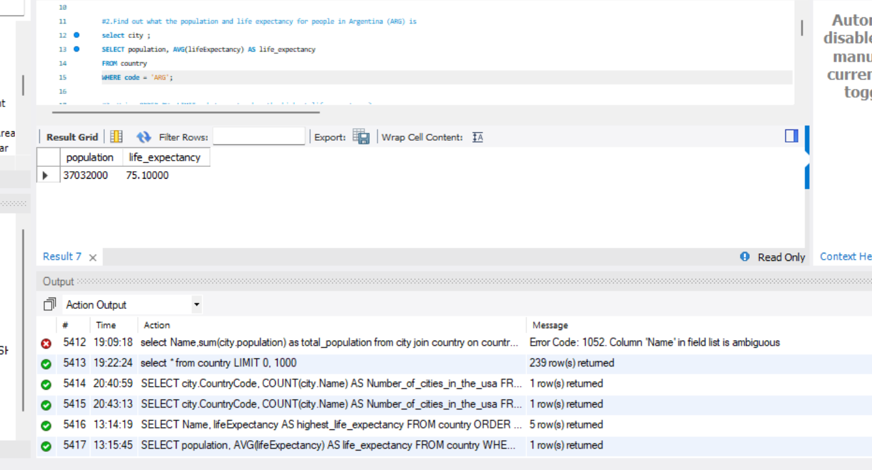

Select Population, find the avergae of life expectancy

From the country’s table and use the where function to filter to filter out Argentina’s output alone

**#3.Using ORDER BY, LIMIT, what country has the highest life expectancy?**

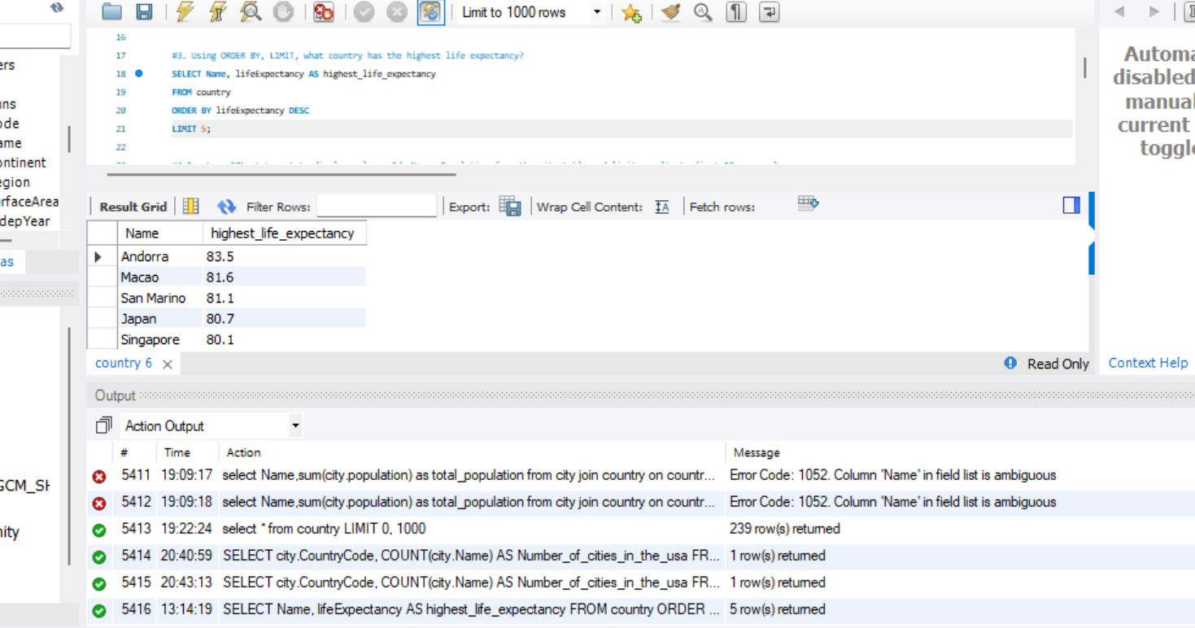

Select statement to access name,life expectancy and assigning an alias for clearer interpretation

Using from country to find the prievous columns in the table country

Order by lifeexpectancy in descding order to attain the highest values easliy as by doing this the values are now reorder in a way that the highest values are at the beginning of the table and then using limit to give an output of the first 5 values.

**#4.Select 25 cities around the world that start with the letter 'F' in a single SQL query.**

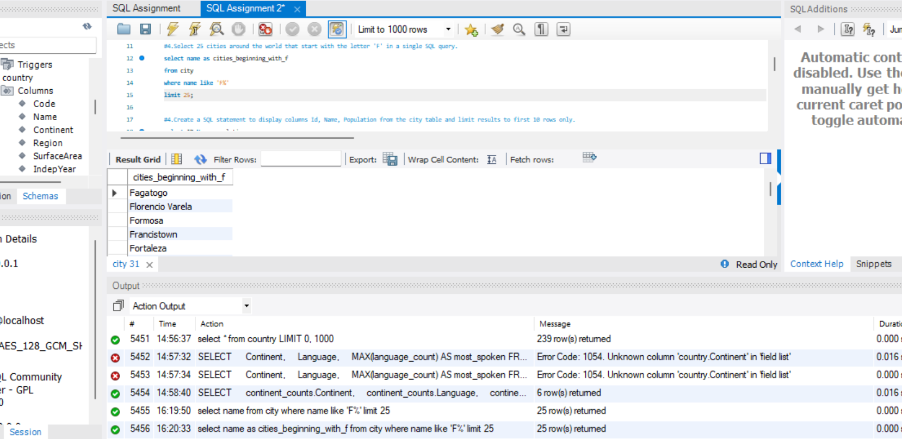

Using the select statement to access name and populaton from the cities table .Then using the where clause to filter the following output to only show an output for populaton in which the values are in between .

**#5.Create a SQL statement to display columns Id, Name, Population from the city table and limit results to first 10 rows only.** 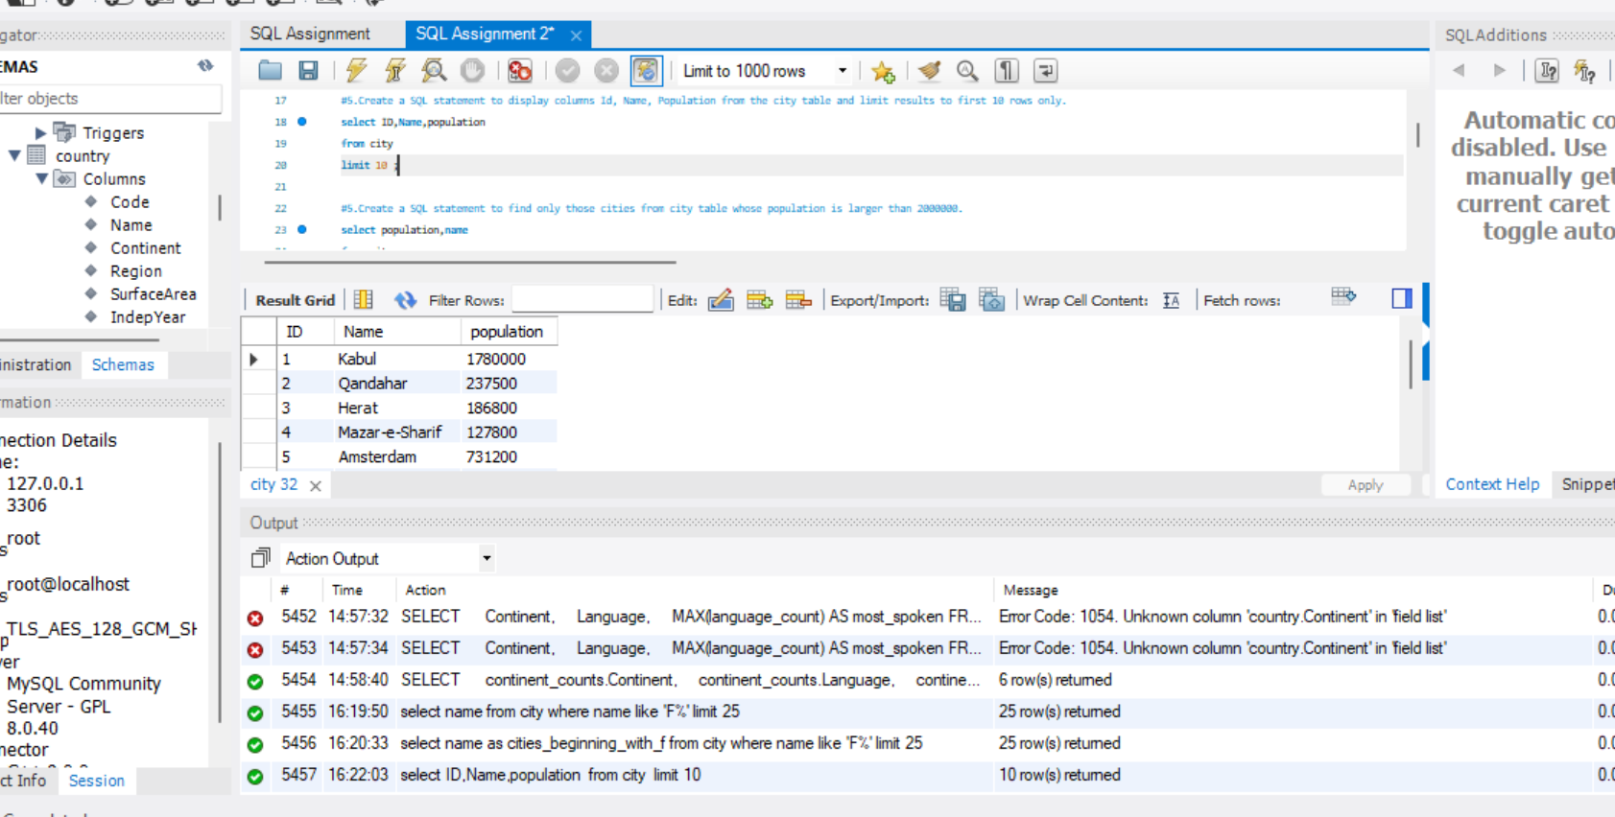

Use the select fuction to access id ,name and population from the city’s table and limit the following output so it shows the first 10 result.

**#6.Create a SQL statement to find only those cities from city table whose population is larger than 2000000.**

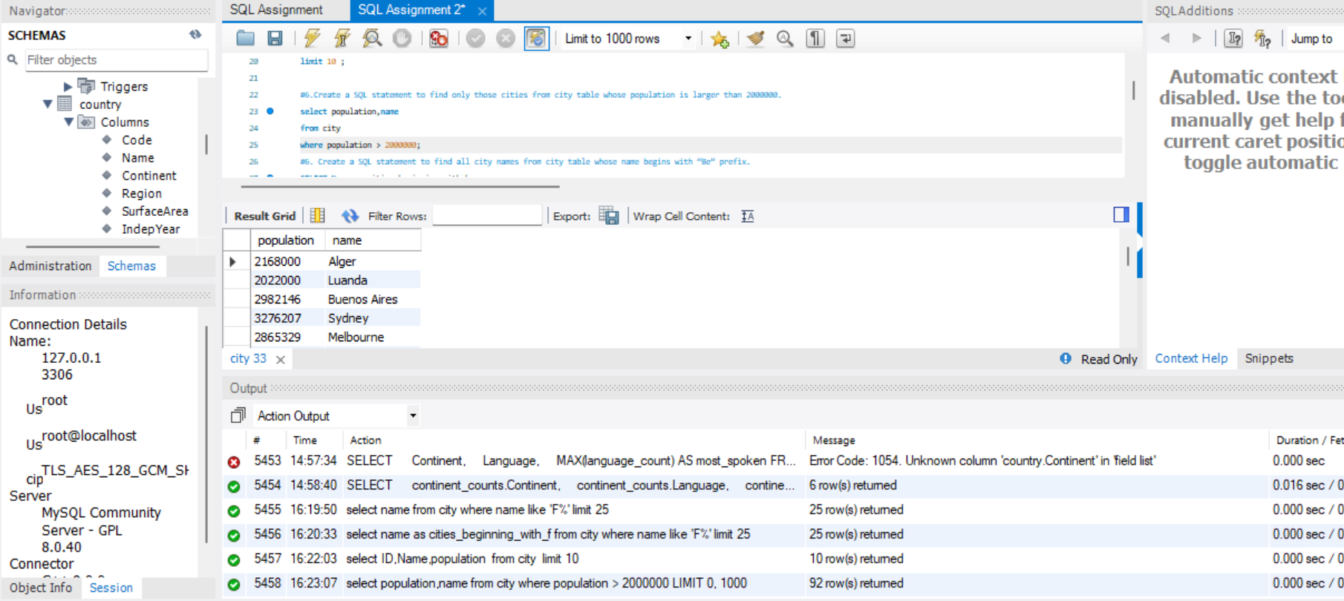

Using the select statement to access population,name, from the city table

Using the where statement to filter the resulting population output to only show results higher than 200000.

**#7.Create a SQL statement to find all city names from city table whose name begins with “Be” prefix.** 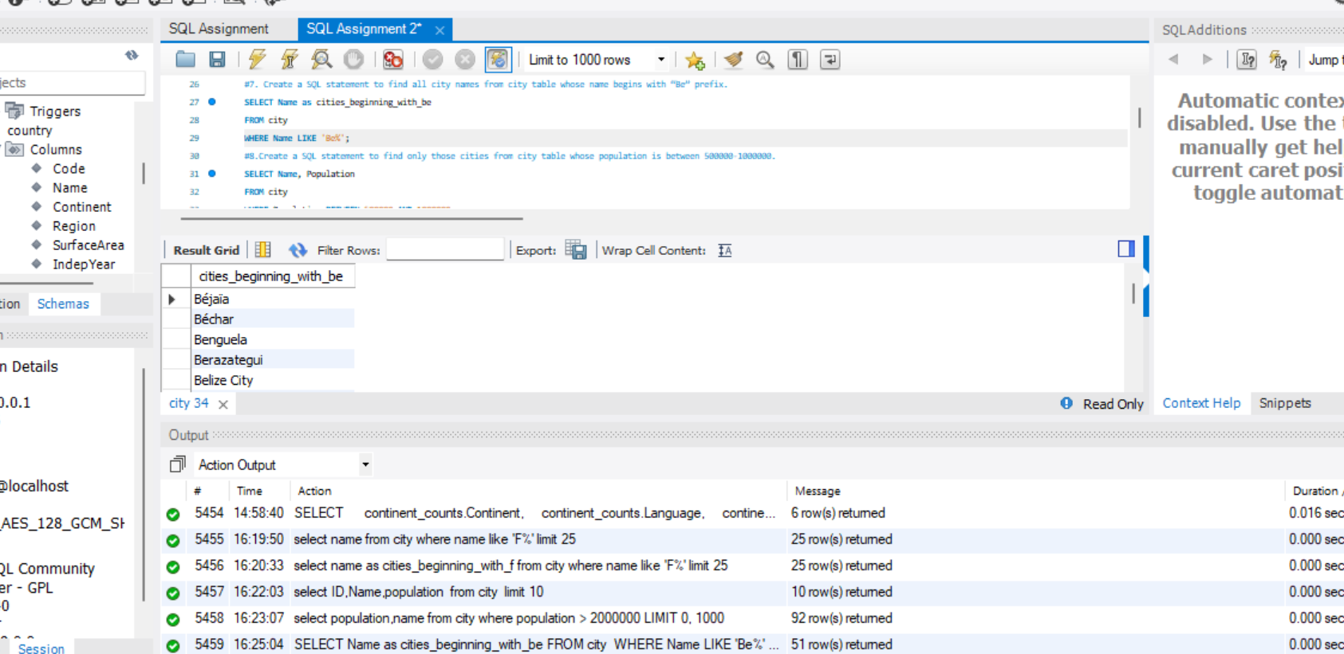

Using the select statement to access/find the name from the cities table and assigning an alias of cities beginning with be for clearer interpretation. Then using the where function to filter the result/output to only include name beginning with be with the position of the percentage sign indicating at which part of the structure to look at %

**#8.Create a SQL statement to find only those cities from city table whose population is between 500000-1000000.**

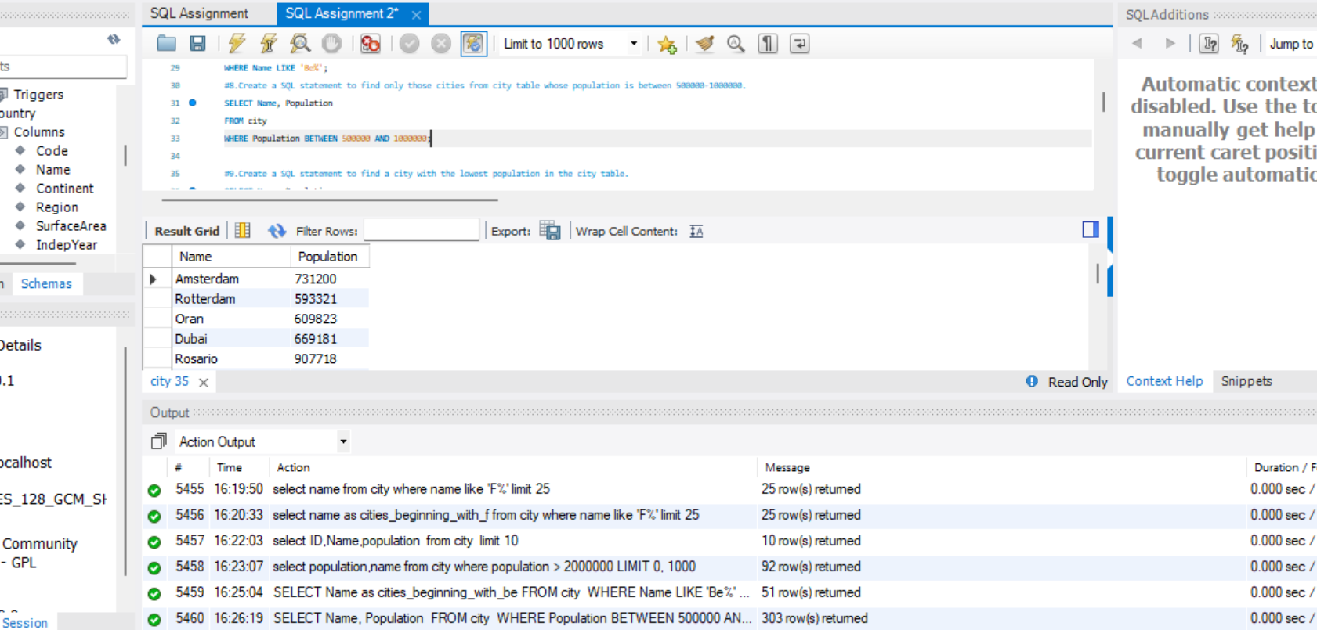

This query retrieves cities with populations between 500,000 and 1,000,000 from the city table. It uses the SELECT statement to specify the columns to be returned (city name and population) and applies a filter with the WHERE clause using the BETWEEN operator to set the population range.

**#9.Create a SQL statement to find a city with the lowest population in the city table.**

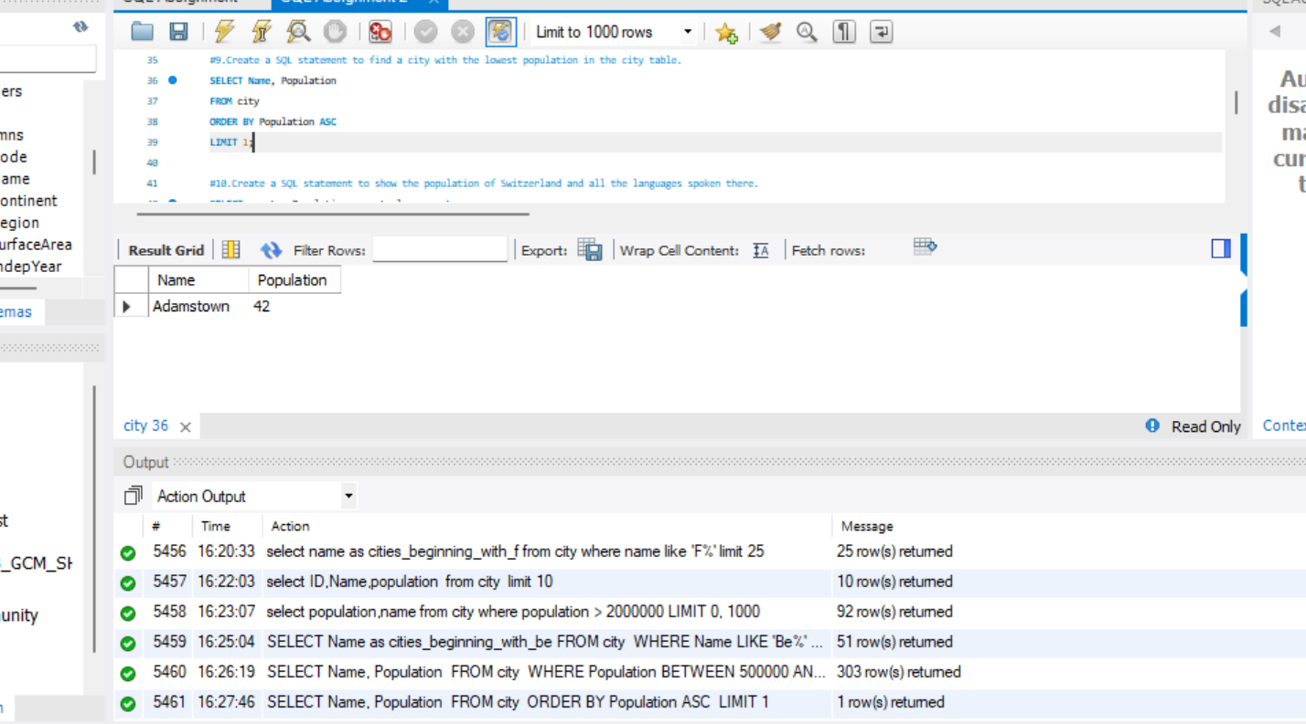

Using the select statement to find the following columns Name,Population from the table city

From then ordering the output by the population table in ASCENDING order meaning the results will be listed in away that the lowest value starts off in the first position and the highest value is last .Laslty using limit 1 to select the lowest value which would be at the top of the results output.

# #10.Create a SQL statement to show the population of Switzerland and all the languages spoken there.

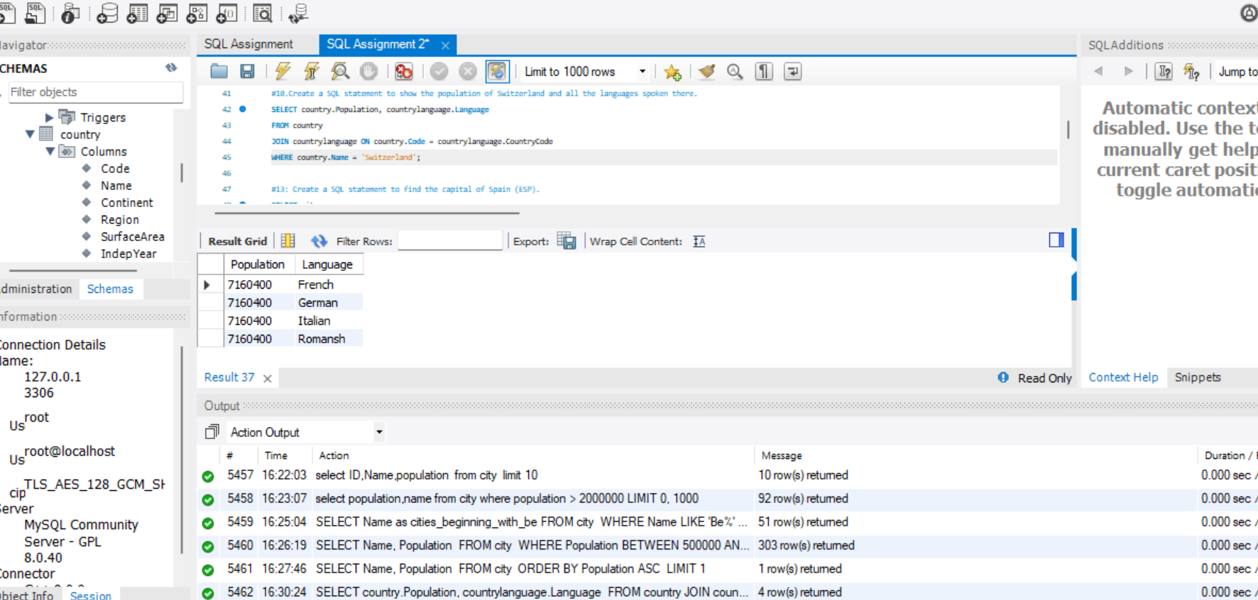

Use the Select clause to find the following columns population, language from country. Then Join statement used to align the following values that have matching values in both tables (country.Code = Countrylanaguage.countrycode.Then using the where clause to extract the following country name ‘Switzterland’.

**Task 13: Create a SQL statement to find the capital of Spain (ESP).**

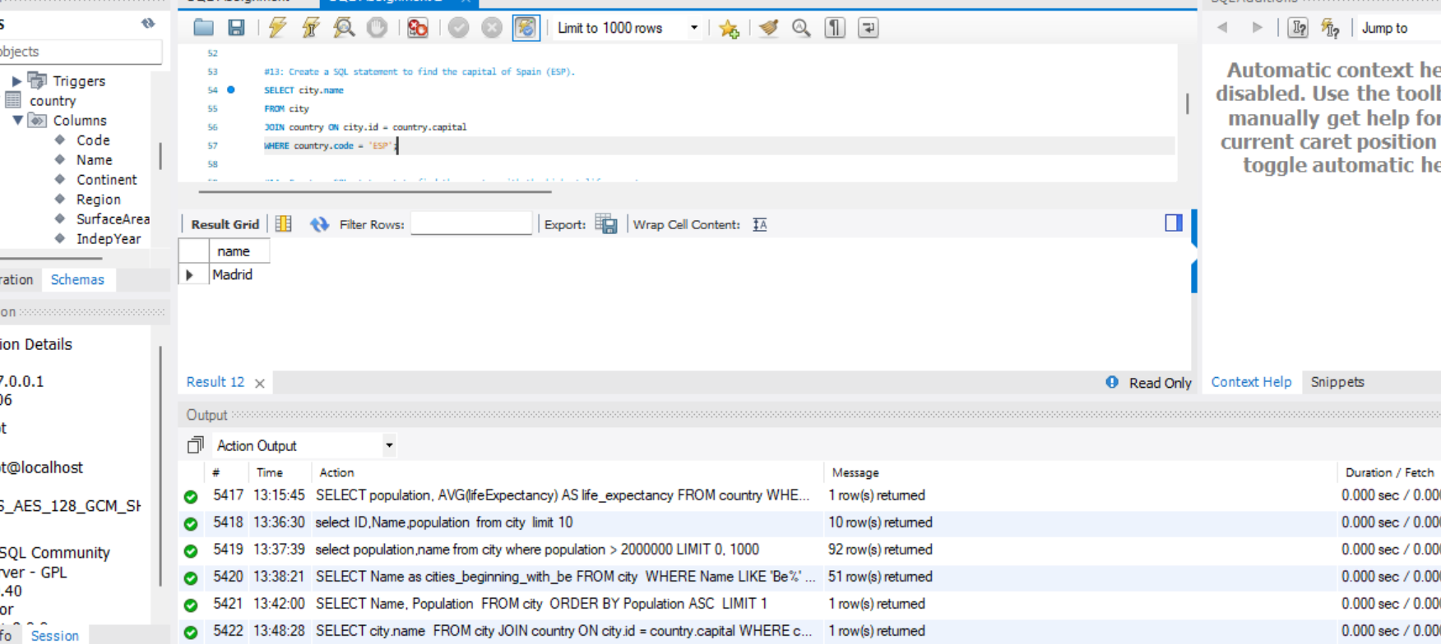

Use the select statement to select the following sub columns in the table city .Then using an inner join to connect the following values from both tables by connecting them via ID = Capital and as a result it only brings back the values seen in both tables.Where clause is used to filter out and extract codes alone that contain ‘ESP’

**Task 14: Create a SQL statement to find the country with the highest life expectancy.**

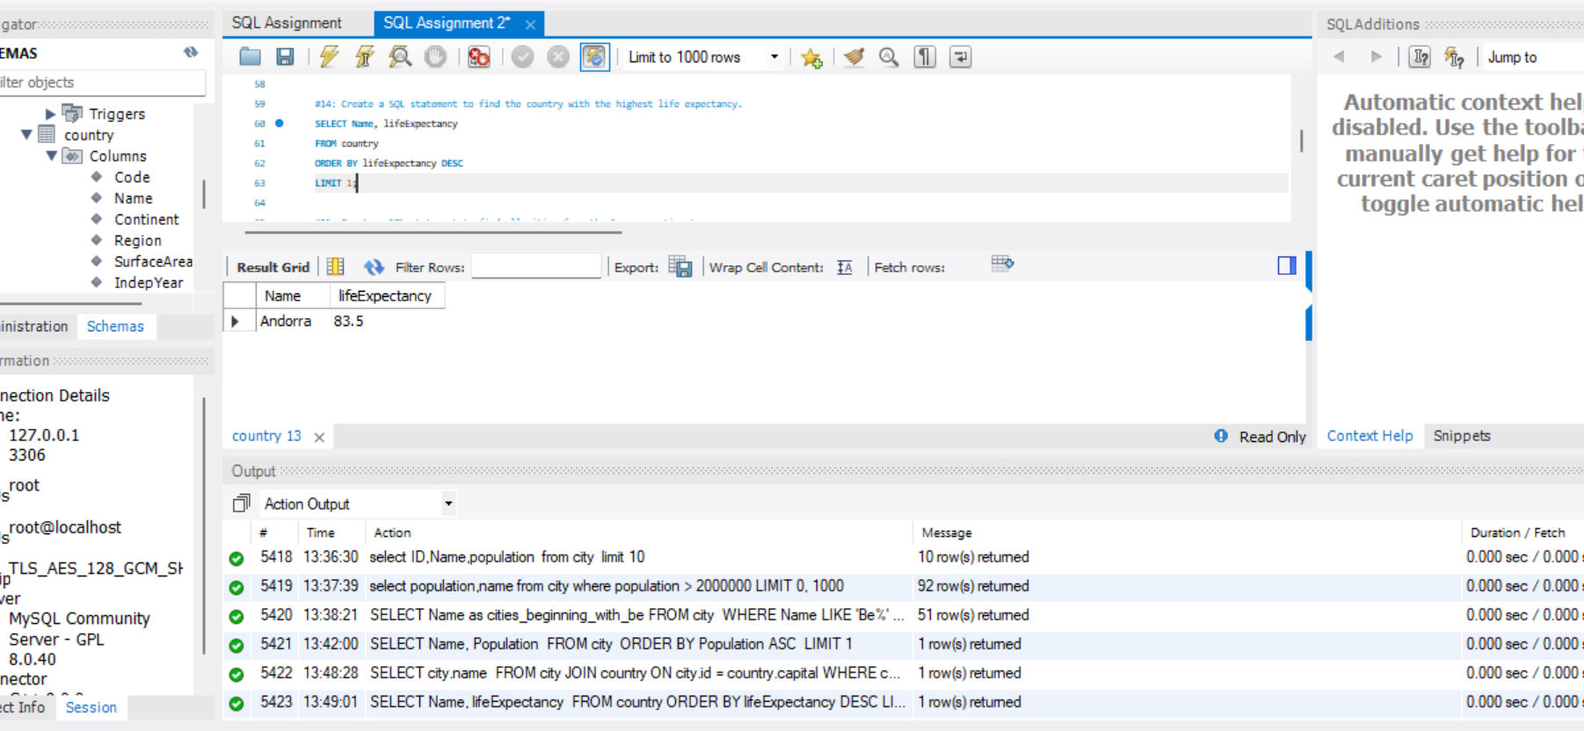

This query selects the country name and its life expectancy from the country table. By ordering the results in descending order (ORDER BY lifeExpectancy DESC), it places the country with the highest life expectancy at the top. The LIMIT 1 clause restricts the output to only the first result, which gives us the country with the highest life expectancy.

**Task 15: Create a SQL statement to find all cities from the Europe continent.**

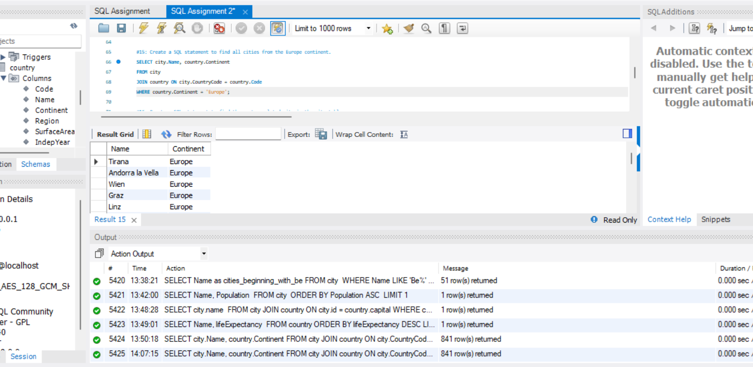

This query retrieves the names of cities and their associated continent from the city and country tables. It uses an INNER JOIN to match records based on the country code. The WHERE clause filters the results to only include cities located in Europe, ensuring we only see relevant data.

**Task 16: Create a SQL statement to find the most populated city in the city table.**

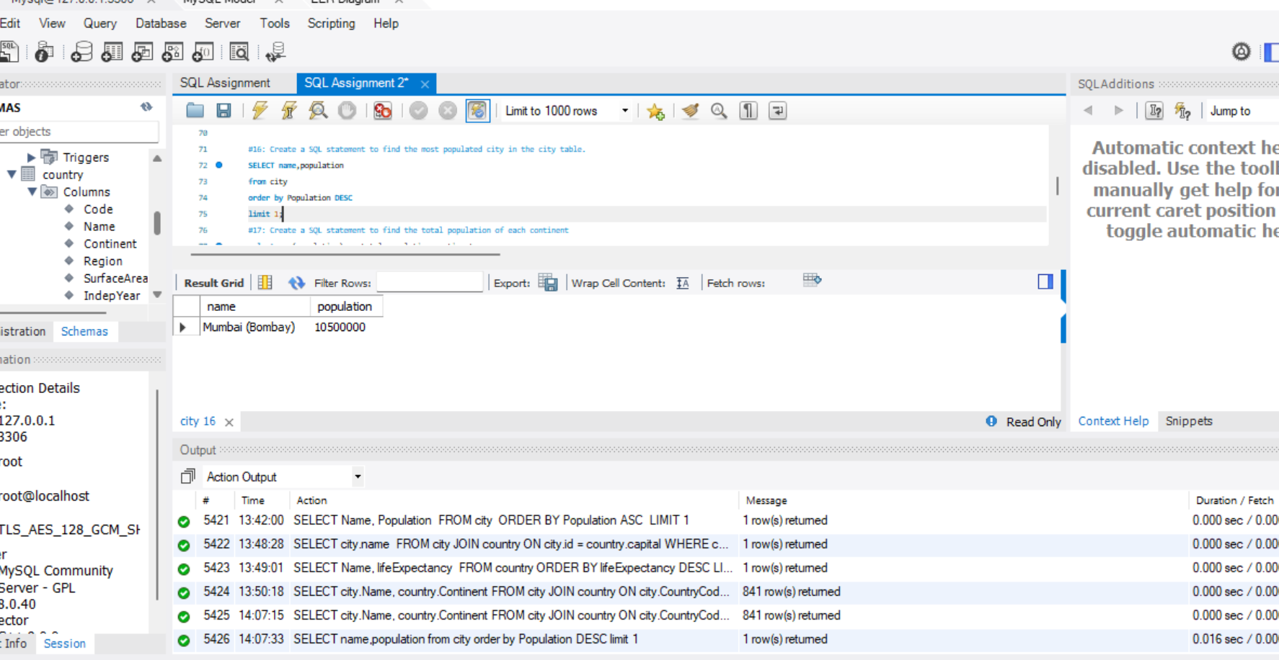

This query selects the city name and its population from the city table. Similar to Query #14, it orders the cities by population in descending order (ORDER BY population DESC) and uses LIMIT 1 to return only the city with the highest population.

**Task 17: Create a SQL statement to find the total population of each continent**

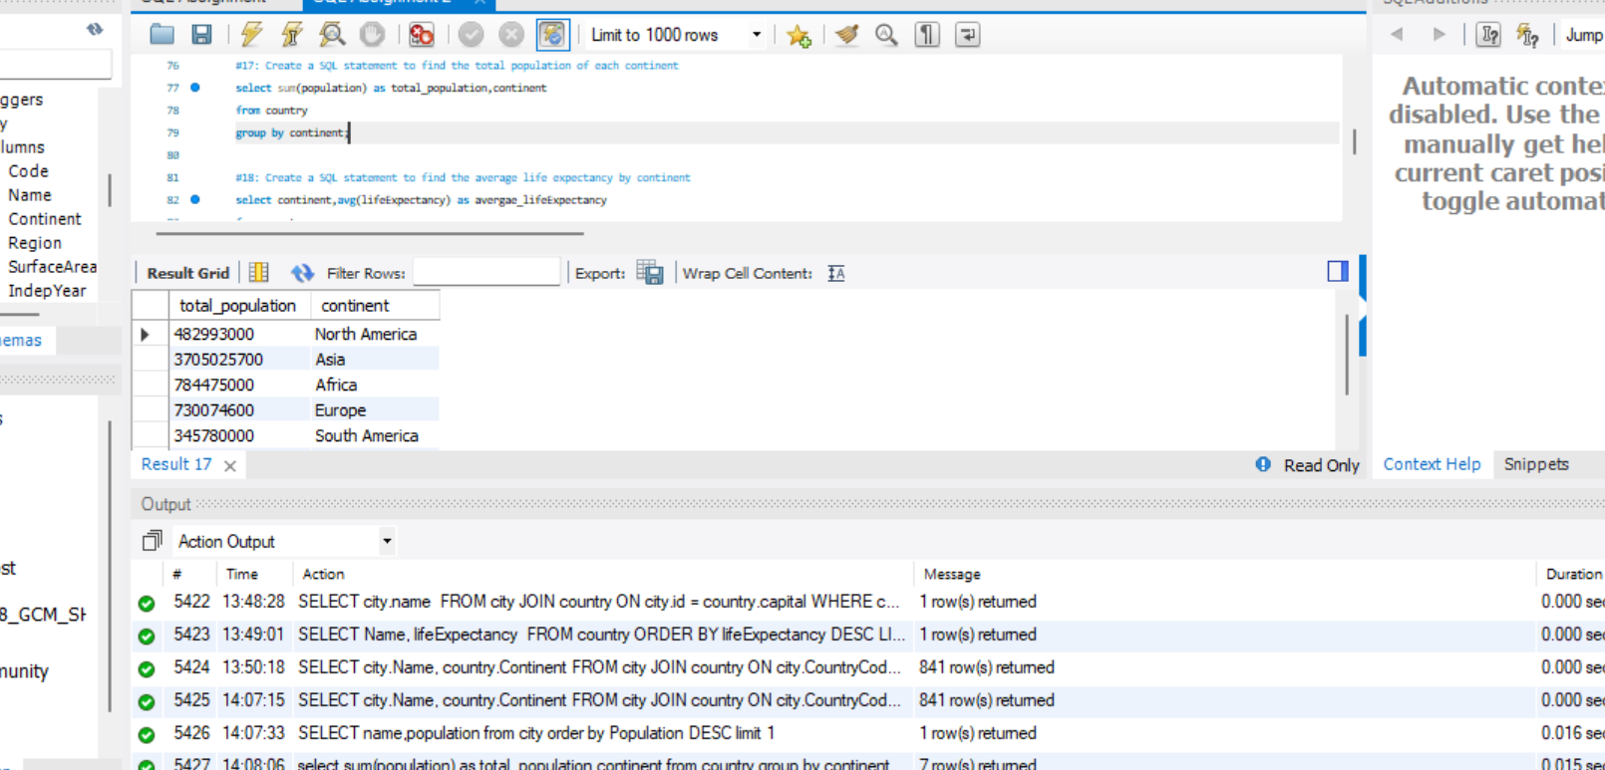

This query calculates the total population for each continent by selecting the sum of the population and continent from the country table. The GROUP BY clause groups the results by continent, enabling the aggregation of population data specific to each continent.

**Task 18: Create a SQL statement to find the average life expectancy by continent**

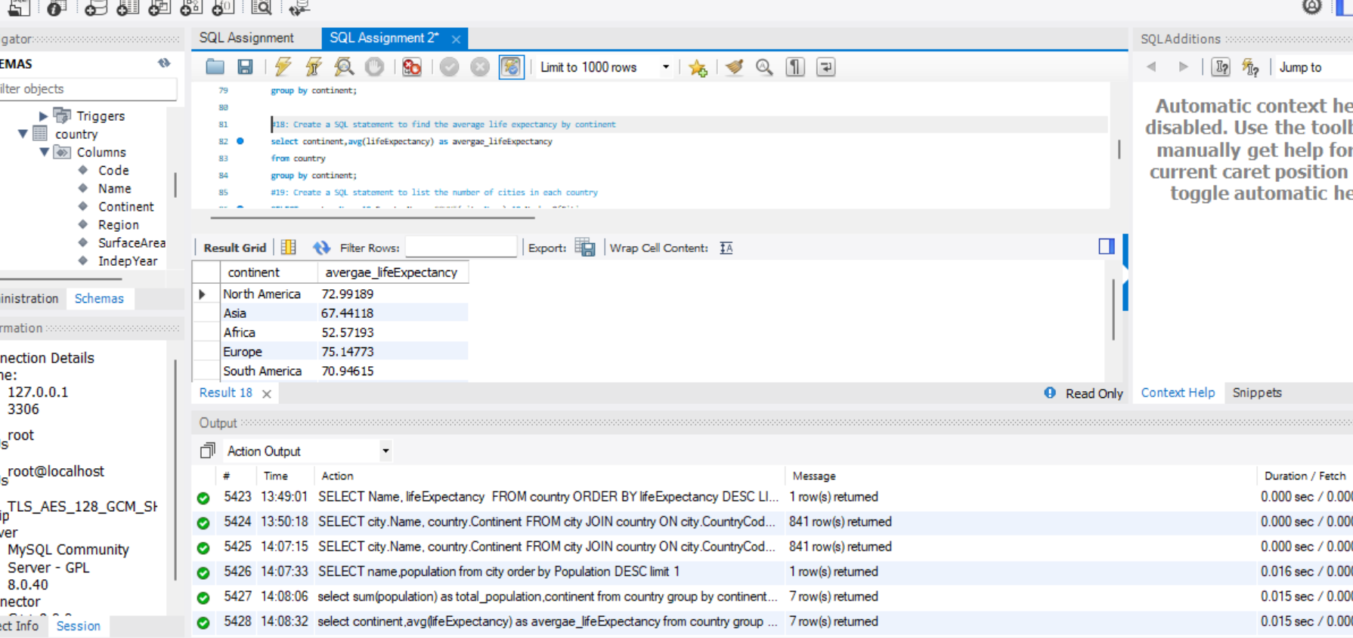

This query finds the average life expectancy for each continent by calculating the average of the lifeExpectancy column. It selects the continent and the computed average while grouping the results by continent with GROUP BY, allowing for aggregation of life expectancy data for each distinct continent.

**Task 19: Create a SQL statement to list the number of cities in each country**

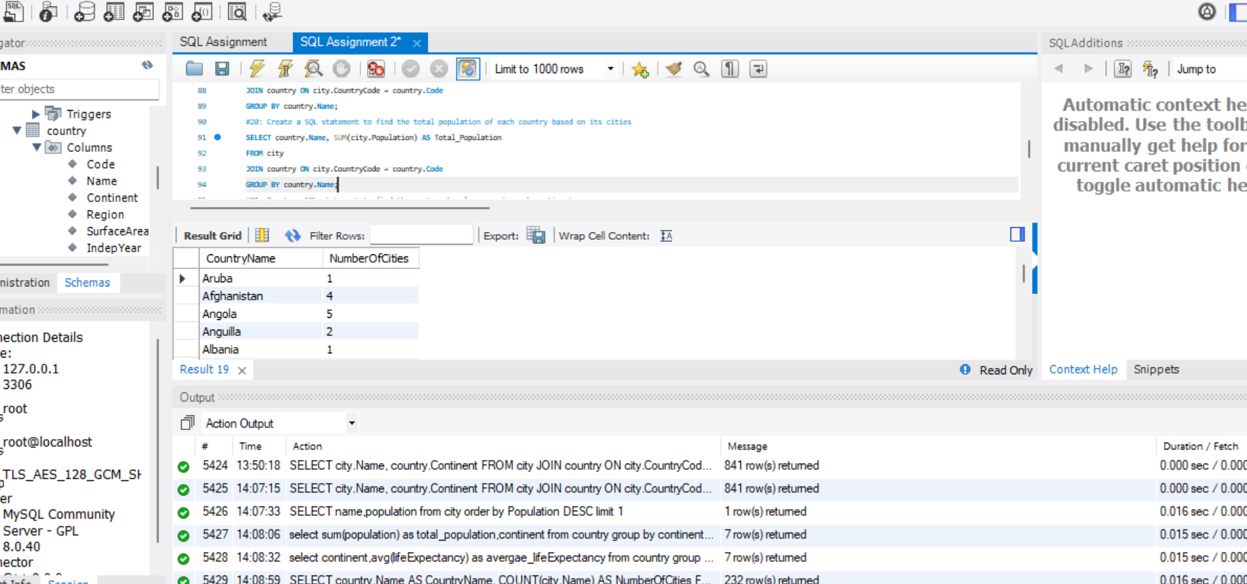

This query counts the number of cities in each country. It uses an INNER JOIN to connect the city and country tables based on the country code. The COUNT(city.Name) function counts the number of cities per country. The results are grouped by the country name using GROUP BY, allowing for a count per country.

**Task 20: Create a SQL statement to find the total population of each country based on its cities**

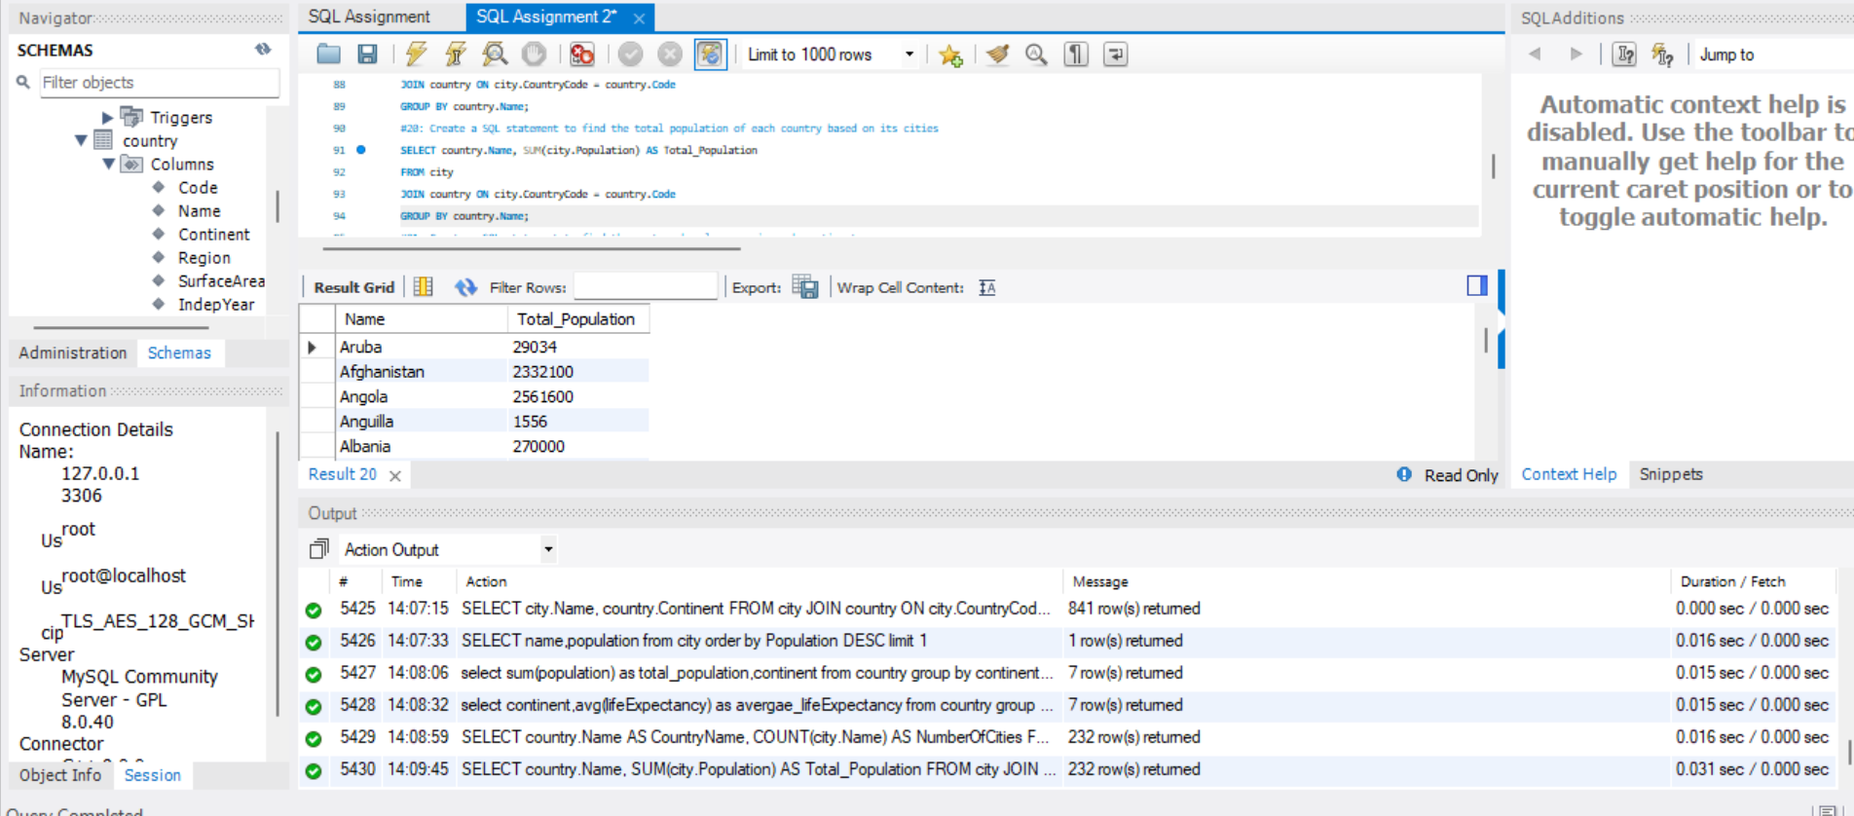

This query calculates the total population for each country based on populations from the city table. It joins the city and country tables on the country code, using SUM(city.Population) to aggregate the total city populations. The GROUP BY clause groups the results by country name, yielding total populations for each respective country.

**Task 21: Create a SQL statement to find the most spoken language in each continent**

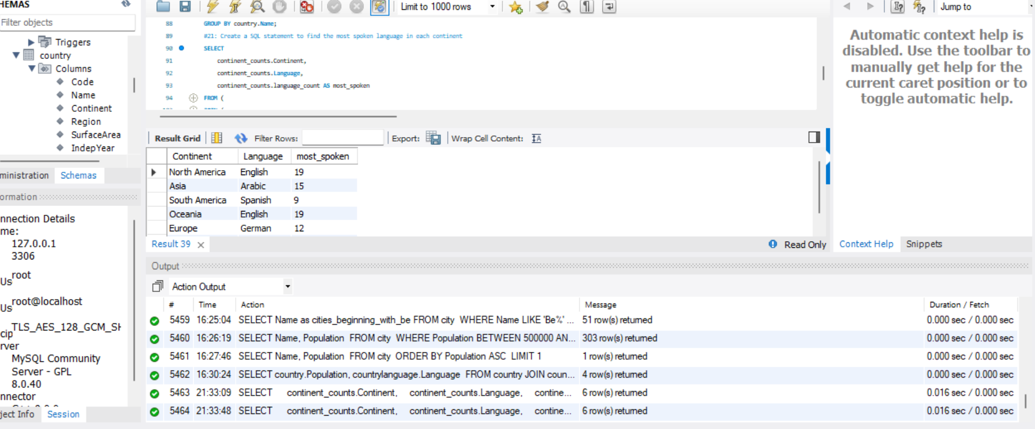

The query counts the number of times each language appears within each continent by joining the countrylanguage and country tables, grouping the results by continent and language. This data is aliased as continent_counts.

A second subquery finds the maximum language count for each continent, which is aliased as max_counts.

Finally, the main query joins these two results on both Continent and language_count, ensuring that only the most frequently spoken languages per continent are selected. The output includes the continent, the most spoken language and its count.

**Task 22: Create a SQL statement to find countries where the official language is either 'English', 'Spanish', or 'French'**

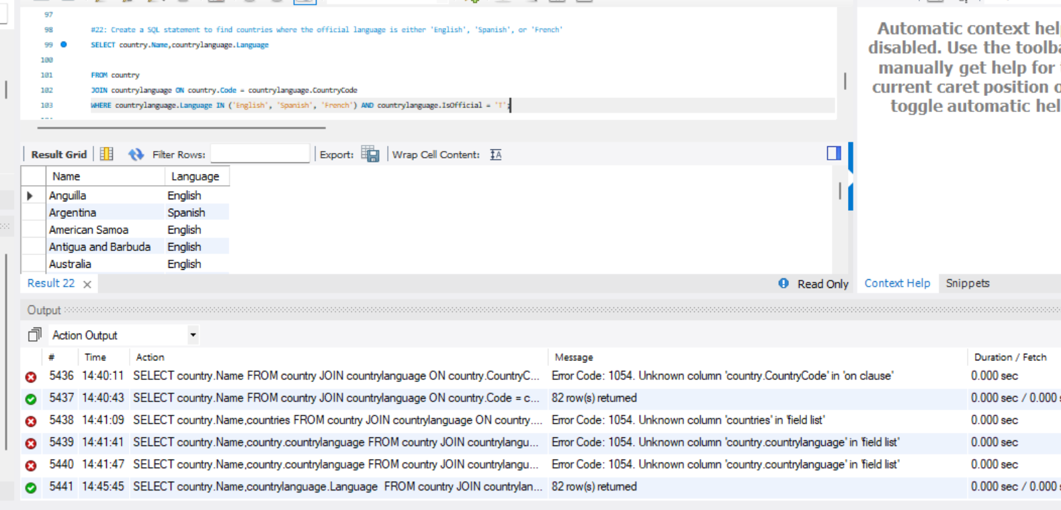

**Task 23: Write a query to display the total population for each continent.** 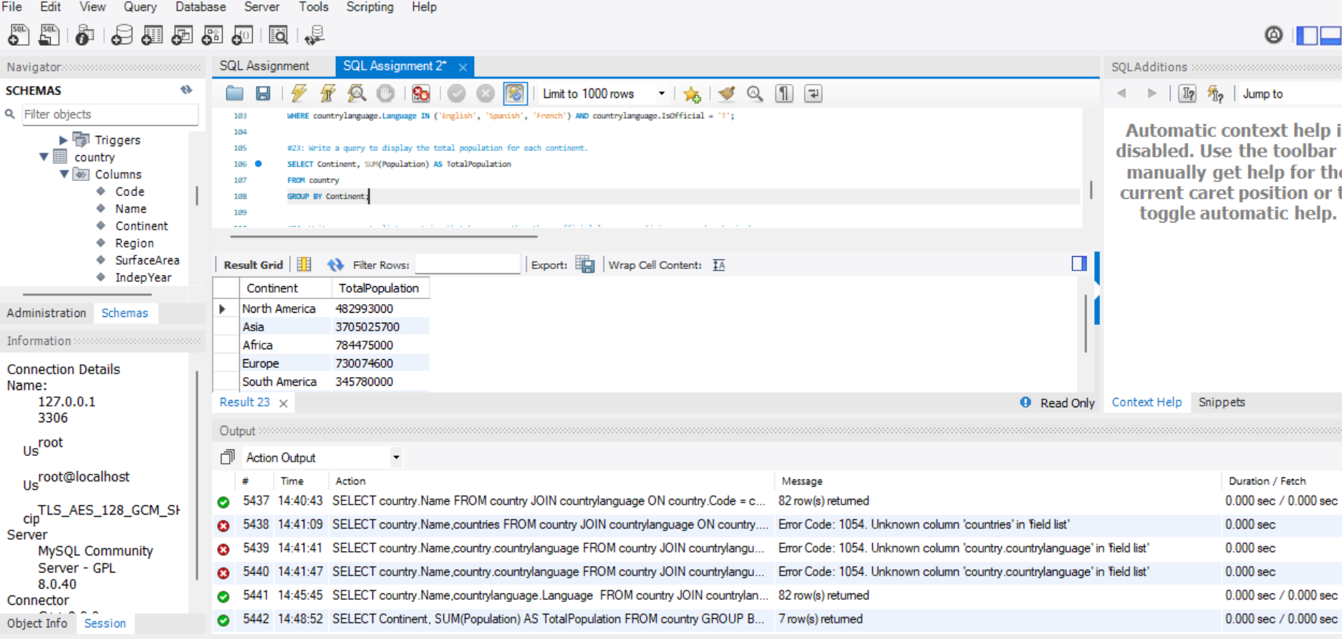

This query calculates the total population for each continent by selecting the continent name and summing the population of countries from the country table. The GROUP BY Continent clause groups the results by continent, allowing the SUM(Population) function to compute the total population for each distinct continent. The result shows the continent along with its total population.

**Task 24: Write a query to list countries that have more than three official languages. (joins, group by, having)**

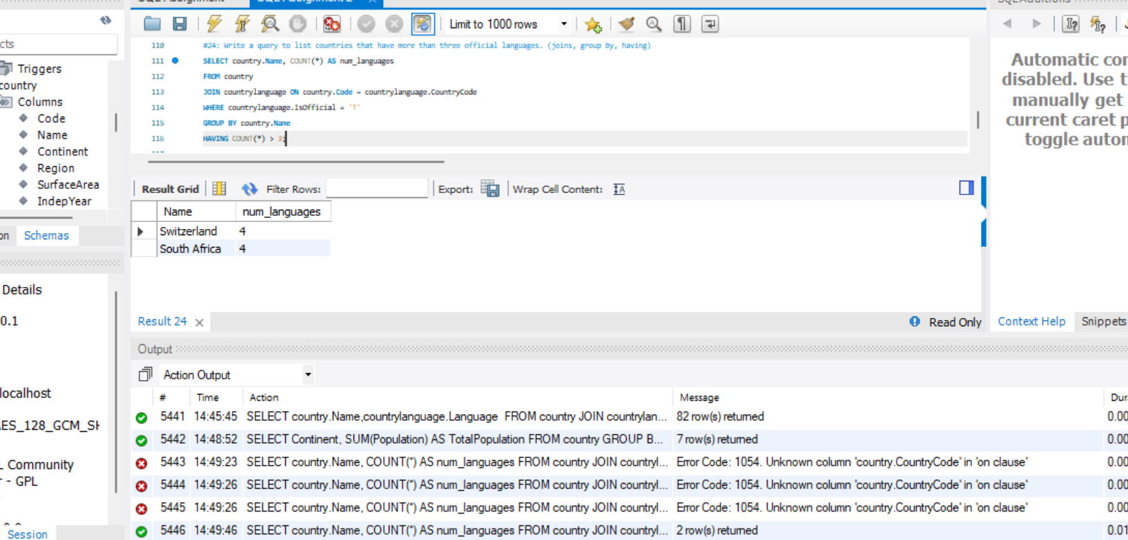

**Task 25: Find countries whose population is greater than the average population of all countries.**

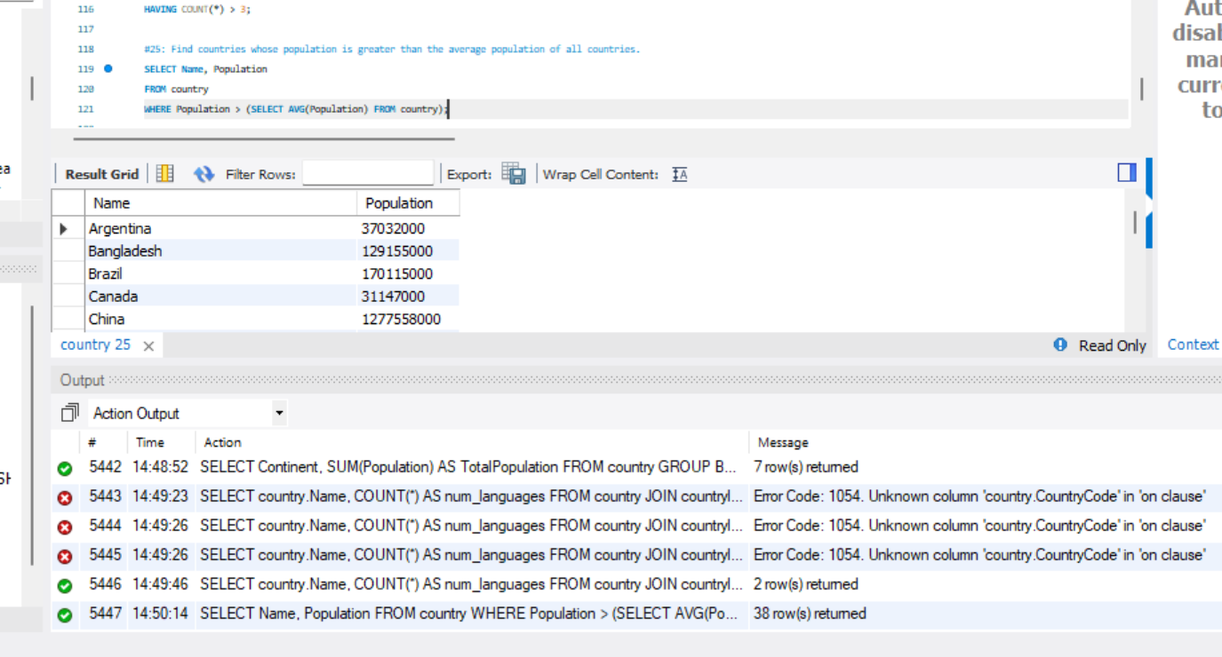

This query retrieves the names of countries that have more than three official languages. It performs a JOIN between the country and countrylanguage tables on the country code to relate the countries to their languages. The WHERE clause filters for only those languages that are marked as official (IsOfficial = 'T'). The GROUP BY country.Name groups the results by country name, and the HAVING COUNT(*) > 3 clause ensures that only those countries with more than three official languages are included in the result set, counting the number of official languages for each country.

# Task 13: Creating an EER Diagram

* Identify the primary key in country table.

Code CHAR(3)

* Identify the primary key in city table.

ID INT

* Identify the primary key in countrylanguage table.

Language CHAR(30)

* Identify the foreign key in city table.

CountryCode CHAR (3)

* Identify the foreign key in countrylanguage table.

Countrycode CHAR(3)



  
  
  
  